**ROBAN SYSTEMS**

**AN HELPING HAND FOR DISABLED PEOPLE**

**A PROJECT REPORT**

submitted by

**Ajay Das K, Fathima Irfana T P, Muhammed Fayis M T, Rabeeh C**

**Register Number: CCV19CS002, CCV19CS007, CCV19CS015, CCV19CS019**

**TO**

The APJ Abdul Kalam Technological University

in partial fulfilment of the requirements for the award of the Degree of

Bachelor Of Technology

In

Computer Science and Engineering



**Department Of Computer Science and Engineering**

**MGM COLLEGE OF ENGINEERING ANDPHARAMACEUTICAL**

**SCIENCES**

VALANCHERY

JANUARY 2023

**DECLARATION**

I undersigned hereby declare that the main project report " **Roban systems - An helping hand for disabled people**", submitted for partial fulfilment of the requirements for the award of the degree of Bachelor of Technology of the APJ Abdul Kalam Technological University, Kerala is a Bonafede work done by me under supervision of **MS NASRIN JUMANA K T**, Asst. Professor, Department of Computer Science and Engineering. This submission represents my ideas in my own words and where ideas or words of others have been included, we have adequately and accurately cited and referenced the sources. We also declare that we have adhered to academic honesty and integrity ethics and have not misrepresented or fabricated any data, idea, fact, or source in our submission. We understand that any violation of the above will causes disciplinary action by the institute and/or the University and can also evoke penal action from the sources that have thus not been properly cited or from whom proper permission has not been obtained. This report has not been previously formed as the basis for the award of any degree, diploma or similar title of any other University.

Place: Valanchery Signature

Date: 06 January 2023 Ajay Das K (CCV19CS002)

Fathima Irfana T P(CCV19CS007)

Muhammed Fayis M T (CCV19CS015)

Rabeeh C (CCV19CS019)

**DEPARTMENT OF COMPUTER SCIENCE AND ENGINEERING MGM COLLEGE OF ENGINEERING AND PHARMACEUTICAL SCIENCES, VALANCHERY**



**CERTIFICATE**

This is to certify that the project report entitled " **Roban Systems - An helping Hand for disabled people**" submitted by Ajay Das K, Fathima Irfana T P, Muhammed Fayis M T, Rabeeh C( CCV19CS002, CCV19CS007, CCV19CS015, CCV19CS019 )to the APJ Abdul Kalam Technological University in partial fulfilment of the requirements for the award of the Degree of Master of Technology in Computer Science and Engineering is a bonafide record of the project work carried out by her under my guidance and supervision during the year 2022- 2023. This report in any form has not been submitted to any other University or Institute for any purpose

Internal Supervisor External Supervisor Head of the Department

**ACKNOWLEDGEMENT**

Alone we can do so little; together we can do so much. Likewise, the present project work has been undertaken and completed with direct and indirect help from many people and I would like to acknowledge the same.

First and foremost, I take immense pleasure in thanking the **Management** and respected principal **DR. PROF BABU JOHN,** for providing me with the wider facilities.

We express our sincere thanks to **MS. MEERA K**, Head of the Department of Computer Science and Engineering for allowing me to present this project and for timely suggestions.

We wish to express my deep sense of gratitude to the project coordinator **MS. MEERA K**, Head of the Department of Computer Science and Engineering, who coordinated on the right path. Words are inadequate in offering my thanks to **MS NASRIN JUMANA K T**, Asst Professor Department of Computer Science and Engineering, for her encouragement and guidance in carrying out the project.

Needless to mention that the teaching and the non-teaching faculty members had been the source of inspiration and timely support in the conduct of our project. We would like to express our heartfelt thanks to our beloved parents for their blessings, and our classmates for their help and wishes for the successful completion of this project.

Above all, we would like to thank the Almighty God for the blessings that helped us to complete the venture smoothly with us. Without their support, it would be impossible for us to finish our work. That is why we wish to dedicate this section to recognize their support.

AJAY DAS K

FATHIMA IRFANA TP

MUHAMMED FAYIS M T

RABEEH C

**ABSTRACT**

Smart home applications are pervasive and have gained popularity due to the overwhelming use of the Internet of Things (IoT). The revolution in IoT technologies made homes more convenient, efficient and perhaps more secure. The need to advance smart home technology is necessary at this stage as IoT is abundantly used in the automation industry. However, most of the proposed solutions are lacking in certain key areas of the system i.e., high interoperability, data independence, privacy, and optimization in general. The use of machine learning algorithms requires high-end hardware and is usually deployed on servers, where computation is convenient, but at the cost of bandwidth. However, more recently edge AI-enabled systems are being proposed to shift the computation burden from the server side to the client side enabling smart devices. In this paper, we take advantage of edge AI-enabled technology to propose a fully featured cohesive system for smart homes based on IoT and edge computing. The proposed system makes use of industry standards adopted for fog computing as well as providing robust responses from connected IoT sensors in a typical smart home. The proposed system employs edge devices as a computational platform in terms of reducing energy costs and providing security, while remotely controlling all appliances behind a secure gateway. A case study of human fall detection is evaluated by a custom lightweight deep neural network architecture implemented over the edge device of the proposed framework. The case study was validated using the Le2i dataset. During the training, the early stopping threshold was achieved with 98% accuracy for the training set and 94% for the validation set. The model size of the network was 6.4 MB which is significantly lower than other networks with similar performance.

Keywords:- Artificial intelligence, Edge intelligence, IoT, Smart home, Deep learning, Human fall detection

**TABLE OF CONTENTS**

**Contents Page No**

**ACKNOWLEDGEMENT**

**ABSTRACT**

**LIST OF FIGURES**

**CHAPTER 1: INTRODUCTION**

**CHAPTER 2: LITERATURE SURVEY**

2.1 Enabling Automation And-Edge Intelligence Over Resource Const 2.2

2.2 Interacting with a Digital Twin using Amazon Alexa

2.3 Amazon Alexa traffic traces

2.4 Iot-Based Electro Synthesis Ecosystem

2.5 Access Control And Surveillance In A Smart Home

2.6 Smart Iot Surveillance Multi-Camera Monitoring System

2.7 Trustbuilder: A Non-Repudiation Scheme For IoT Cloud Applications

2.8 Accuracy Determination Using Deep Learning Technique In the Cloud-

Based Iot Sensor Environment

2.9 Self-Secured Model For Cloud-Based IOT Systems

2.10 Taking MQTT And Nodemcu To IOT: Communication In the Internet Of Things

**CHAPTER 3: MODULES**

3.1 Bed and Ventilation Module

3.2 Basic Needs Module

3.3 Patient Monitor Module

3.4 Medical Aid Module

3.5 security and Entertainment Module

**CHAPTER 1**

**INTRODUCTION**

Over the last few decades, many researchers have focused on connecting everyday objects and weaving a web of interconnected devices. These can be physical devices, automobiles, embedded systems or everyday home appliances. The connectivity of these devices is enabled by the underlying technology known as the Internet of Things (IoT) [1]. These devices can communicate with one another and seamlessly collect and transfer data in between to adapt and reciprocate to dynamic situations. The IoT is gaining tremendous traction from the IT industry as well as individual enthusiasts alike. This is because microcontroller technologies have evolved that enable these complex infrastructures and are more accessible to average developers. The use of single board computers also refers to as System on Chip (SoC) in IoT-based systems, enables rapid interconnection of environmental sensors and decent computational capabilities along with vision sensors that make it easy to develop fairly in large applications. Advancements in machine learning algorithms for mobile and low-power devices also pave the way for intelligent devices in IoT systems. A typical home automation system connects heterogeneous devices, collects data, and decides based on the observed data from these sensors. The means of communication between these devices is typically Wi-Fi or Bluetooth and in some cases a cellular network (3G/4G/5G) [2]. We were focusing on how IoT can drastically improve the lives of disabled people by addressing limited access in many ways. We also spoke about how smart homes and home automation systems are rising in popularity, allowing people to control various aspects of their homes from a single place without getting up. However, for disabled people, this technology holds much more significance. It is not adding additional value but solving some of their biggest hurdles like being unable to access specific items or devices. Smart homes single-handedly allow disabled people to live more independently with an easy-access lifestyle. With the sophistication of IoT technology, it has become a possibility for disabled people to rely lesser on their caregivers

**CHAPTER 2**

**LITERATURE SURVEY**

**2.1 Enabling Automation And-Edge Intelligence Over Resource Const**

Smart home applications are pervasive and have gained popularity due to the overwhelming use of the Internet of Things (IoT). The revolution in IoT technologies made homes more convenient, efficient and perhaps more secure. The need to advance smart home technology is necessary at this stage as IoT is abundantly used in the automation industry. However, most of the proposed solutions are lacking in certain key areas of the system i.e., high interoperability, data independence, privacy, and optimization in general. The use of machine learning algorithms requires high-end hardware and is usually deployed on servers, where computation is convenient, but at the cost of bandwidth. However, more recently edge AI-enabled systems are being proposed to shift the computation burden from the server side to the client side enabling smart devices. In this paper, we take advantage of edge AI-enabled technology to propose a fully featured cohesive system for smart homes based on IoT and edge computing. The proposed system makes use of industry standards adopted for fog computing as well as providing robust responses from connected IoT sensors in a typical smart home. The proposed system employs edge devices as a computational platform in terms of reducing energy costs and providing security, while remotely controlling all appliances behind a secure gateway. A case study of human fall detection is evaluated by a custom lightweight deep neural network architecture implemented over the edge device of the proposed framework. The case study was validated using the Le2i dataset. During the training, the early stopping threshold was achieved with 98% accuracy for the training set and 94% for the validation set. The model size of the network was 6.4 MB which is significantly lower than other networks with similar performance.

**2.2 Interacting with a Digital Twin using Amazon Alexa**

The Digital Twin is an evolving concept with many facets and applications, for instance, engineering simulation, system control, and product-centric information management. This article focuses on the latter where literature uses the Product Avatar concept to refer to a product's digital counterpart. Such an avatar used to have one or more graphical interfaces to support user interactions with information about a product item. Over the last few years, voice user interfaces became more mature, and companies, such as Amazon and Google, used them to create digital assistants that support their users during tasks or by taking them over directly. This paper focuses on the hypothesis that a company could use a voice-enabled digital assistant to interact with item-level information. Our study used product tracking and tracing, and quality control in the production as a realistic application case. The design of the assistant is based on the information needs outlined in the Electronic Product Code Information Services (EPCIS) standard. We implemented this design in a small-scale demonstrator on an Echo Show 5 smart speaker with an integrated touch display and an embedded Amazon Alexa assistant. This paper concludes that significant technological barriers, such as low transcription accuracy for object identifier information and the handling of factory noise, remain. A significant non-technological barrier is the mistrust regarding the closed voice assistant technologies from companies, such as Amazon and Google. An approach to address the latter barrier is to use open technologies, such as the privacy-focused assistant Mycroft or Mozilla's transcription solution DeepSpeech.

**2.3 Amazon Alexa traffic traces**

The number of devices that make up the Internet of Things (IoT) has been increasing every year, including smart speakers such as Amazon Echo devices. These devices have become very popular around the world where users with a smart speaker are estimated to be about 83 million in 2020. However, there has also been great concern about how they can affect the privacy and security of their users [1]. Responding to voice commands requires devices to continuously listen for the corresponding wake word, with the privacy implications that this entails. Additionally, the interactions that users may have with the virtual assistant can reveal private information about the user. In this document, we publicly share two datasets that can help conduct privacy and security studies on the Amazon Echo Dot smart speaker. The included data contains 300.000 raw PCAP traces containing all the communications between the device and Amazon servers from 100 different voice commands in two different languages. The data can be used to train machine learning algorithms to find patterns that can characterize both, the voice commands and people using the device as well as Alexa as the device generating the traffic.

**2.4 Iot-Based Electro Synthesis Ecosystem**

In this paper, we presented the electro-synthesis ecosystem using esp8266 with OTA com- pilation integrated, the MQTT Broker for the control system that would be installed on a Raspberry Pi and MQTT protocol for the wireless data transfer layer which provides the electrosynthesis machine to work 24/7 and with the AI that can be implemented, the whole ecosystem would be smart and the data-driven can be used in QC verification. This system is designed and simulated and the source codes are available via GitHub (https://github.com/iraniothome/ChemIoT).

**2.5 Access Control And Surveillance In A Smart Home**

In the past years, smart home solutions have become more and more popular with the introduction of a high number of both Internet of Things (IoT) applications and smart devices. The home automation and security systems market is in continuous growth, traditional security systems are evolving fast, and more and more people choose Smart home solutions. In this paper, we propose two IoT-based systems in the context of Smart homes: qToggle for multiple home automation, and MotionEyeOS, a video surveillance OS for single-board computers. Most goggle devices are based on ESP8266/ESP8285 chips or Raspberry Pi boards and smart sensors, while MotionEye uses Raspberry Pi boards.

**2.6 Smart Iot Surveillance Multi-Camera Monitoring System**

The surveillance digital monitoring process market has changed aggressively over the last 15 years. Where the process was needed for people to secure their businesses by a simple surveillance camera system to give them that much-needed peace of mind. However, the existing monitoring systems are very expensive due to internal specific SDK configuration which was embedded in the camera itself. Some of them provide a solution such as a high-priced customized command centre that has several screens view which communicate with several cameras to monitor the cameras with a specific detection analysis module. In this paper, a cheaper solution to the monitoring system for existing surveillance cameras is introduced to overcome the solution. This system only implements open-source image processing methods to produce a monitoring system with customizable modules for video analytics (video content analysis) with the input of live video sources. This is to allow a wider range of camera models that can be used for this system. A real-time analysis module will assist in the use of the system to ease the user. The combined video stream and the module will help the user immensely for surveillance propose. Based on the result, the proposed system achieved a higher affordability level of up to 95% with 90% usability compared to existing products.

**2.7 Trustbuilder: A Non-Repudiation Scheme For IoT Cloud Applications**

The IoT cloud computing paradigm is emerging for IoT applications. In such a paradigm, how to guarantee non-repudiation service provisioning has attracted research efforts recently. While existing solutions could work for distributed IoT cloud applications, storage, computation, and economic cost are still a practical challenging concern. In this paper, we propose a new, cost-lower non-repudiation scheme for IoT cloud applications. The proposed scheme guarantees that neither the IoT client nor the cloud could re-repudiate a service enjoyment and provisioning. Specifically, the proposed scheme employs a blockchain to achieve non-repudiation. First, when the cloud provides a service, it encrypts the service, stores a cryptographic hash digest of the encrypted service on the blockchain, and then sends the encrypted service to the IoT client. Second, the IoT client needs to acknowledge the hash digest on the blockchain to ob- in the service. Third, the cloud sends the decryption key to the blockchain under the IoT client’s public key to finish service provisioning. We show that the proposed scheme achieves non-repudiation fairly. We prototyped, evaluated, and open-sourced the proposed scheme. Experimental results confirmed the efficiency of the proposed scheme and the speedup compared with the state-of-the-art solution.

**2.8 Accuracy Determination Using Deep Learning Technique In Cloud-Based Iot Sensor Environment**

devices. However, when connected to wireless connections, unlimited access to IoT gadgets poses potential risks. As it eases cost constraints on sensor nodes, the cloud service with IoT networks has received greater attention. In addition, the high complexity of the distribution and networking of IoT makes them vulnerable to attacks. Intrusion detection systems (IDSs) are selected to ensure the security of reliable information and operations. IDS successfully detects anomalies in complex network situations and guarantees network security. Deep Convolution Network (DCN) IDS have a slow learning curve and poor categorization precision. Deep Learning (DL) methods are often used in a wide range of safety data processing, imaging, and signal processing like Poor transfer learning ability, reusability of modules, and integration. To overcome the constraints of Machine Learning (ML) IDS is intended to provide a comprehensive mechanism to learn the detection mechanism for multi-cloud IoT environments. The proposed IDS approach increases training efficiencies while increasing detection accuracy. Experimental investigations of the proposed system using the considered database confirms that the performance of the proposed system is capable and in the range of acceptance relative to existing methods. Further, achieving detection capability, reliability, and accuracy of 97.51, 96.28, and 94.41% respectively are achieved.

**2.9 Self-Secured Model For Cloud-Based IOT Systems**

A difficult problem to solve concerns the secure installation and startup of devices connected to the Internet of Things (IoT) via the Internet. To provide additional value-added services, this article deals with the verified configuration of IoT devices in a secure manner using the Internet. Following a review of the safe self-configuration limitations imposed on IoT and Cloud technologies; offer a Cloud-based architecture that enables the communication between IoT devices and several federated Cloud services. Specifically discuss two situations, one cloud environment and federated cloud infrastructure interact with IoT devices, and handle unique issues. In addition, it provides many operational design features that take into account the truly open hardware and software products already on the market.

**2.10 Taking MQTT And Nodemcu To IOT: Communication In the Internet Of Things**

The Internet of Things (IoT) allows connection among devices using the Internet with the ability to gather and exchange data. These devices are usually attached with micro-controllers like Arduino, sensors, actuators and internet connectivity. In this context, Message Queuing Telemetry Transport protocol (MQTT) plays an important role to exchange the data or information between the devices in IoT without knowing the identities of each other. This paper presents different service models for communication in the Internet of Things(IoT). Model A presents the use of serial USB as a transmission medium while Model B uses the Message Queuing Telemetry Transport protocol (MQTT) which deploys a Wi-Fi module (ESP8266-12) to connect the system to the internet. For communication, the concept of publisher and subscriber is used. Messages are published or subscribed with the help of a broker or server. This agent is in charge of dispersing messages to intent clients depending on the choice of the topic of a message. The broker in MQTT is also called the server. Some brokers used in MQTT are: -Mosquitto, Adafruit, hiveMQ

**CHAPTER 3**

5

4

2

1

3

**MODULES AND REQUIREMENTS**

Bed

and Ventilation

Medical

Aid

Basic

Needs

Security and Entertainment

Patient Monitor

Fig 3 Modules of Roban System

#### 3.1 Bed and Ventilation Module

#### The bed and ventilation module is used to adjust the bed position and adjust the ventilation by sliding the curtains. Disabled people can adjust the bed positions by themselves through voice commands, so they can acquire their comfortable positions. By controlling the ventilation system by voice command they can adjust the natural lighting and ventilation.

#### 

#### 3.2 Basic Needs Module

#### The basic need module consists of an Artificial ventilation system like fans, or exhaust fans, a lighting system like AC and DC lights, warm lights and a pest control system. Disabled people can adjust the bed positions by themselves through voice commands so they can full fill their needs using the IoT

#### 

#### 3.3 Patient Monitor Module

#### This module consists of several sensors that are connected over IoT, and by that sensor, we can monitor the patient’s health and make health plans and it can also alert the authorities when there are any emergencies happen. We can implement patient monitoring like temp, oxygen, pulse, etc. and monitor the environment of the patient.

#### 

#### 3.4 Medical Aid Module

#### This module can automate or remote the essential medical supply like medicines, oxygen, water etc. This is done by the multiple relays and solenoid valve pumps etc.

#### 

#### 3.5 security and Entertainment Module

Disabled people are seen in a closed environment so there is a chance of mental depression. So we connect entertainment like TV, social media, and streaming platforms in this module Disabled people can use them through voice commands. And security is also essential for them so we connected a security camera we can use this camera to monitor the patient’s external and internal environment.

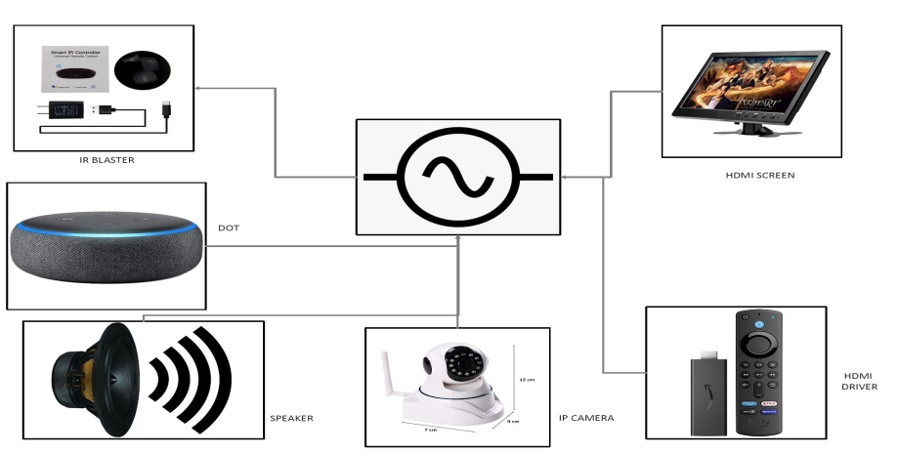

#### 3.6 Requirements

**3.6.1 system configuration**

The system must be full fill the configuration of 4GB RAM and a minimum operating system of Windows 7 or more.

**3.6.2 C++ language**

As Arduino. began developing new MCU boards based on non-AVR processors like the ARM/SAM MCU used in the Arduino Due, they needed to modify the Arduino IDE so it would be relatively easy to change the IDE to support alternate toolchains to allow Arduino C/C++ to be compiled for these new processors. They did this with the introduction of the Board Manager and the SAM Core. A "core" is the collection of software components required by the Board Manager and the Arduino IDE to compile an Arduino C/C++ source file for the target MCU's machine language**.**

**3.6.3** **Alexa**

Alexa Voice Service (AVS) Integration is a new feature of AWS IoT Core that enables device makers to make any connected device an Alexa Built-in device. AVS for AWS IoT reduces both the cost and complexity of producing Alexa Built-in devices by offloading compute and memory-intensive tasks from physical devices to the cloud. With the reduction in the engineering bill of materials (BOM) cost, device makers can now cost-effectively build new categories of differentiated voice-enabled products such as light switches, thermostats, small appliances and more. This allows end-consumers to talk directly to Alexa in new parts of their home, office, or hotel rooms for a truly ambient experience.

**3.6.4** **Blynk platform**

Everything you need to build and manage connected hardware: device provisioning, sensor data visualization, remote control with mobile and web applications, Over-The-Air firmware updates, secure cloud, data analytics, user and access management, alerts, automation and much more.Blynk platform powers low-batch manufacturers of smart home products, complex HVAC systems, agricultural equipment, and everyone in between. These companies build branded apps with no code and get the full back-end IoT infrastructure through one web app.

**3.6.5** **The Arduino Integrated Development Environment**

The Arduino Integrated Development Environment - or Arduino Software (IDE) - contains a text editor for writing code, a message area, a text console, a toolbar with buttons for common functions and a series of menus. It connects to the Arduino hardware to upload programs and communicate with them.

**3.6.6 The Proteus Design Suite**

The Proteus Design Suite is a proprietary software tool suite used primarily for electronic design automation. The software is used mainly by electronic design engineers and technicians to create schematics and electronic prints for manufacturing printed circuit boards.

**3.6.7 Node MCU**

NodeMCU is a low-cost open-source IoT platform. It initially included firmware which runs on the ESP8266 Wi-Fi SoC from Espressif Systems, and hardware which was based on the ESP-12 module. Later, support for the ESP32 32-bit MCU was added.

**3.6.8 Sensors**

A sensor is a device that detects and responds to some type of input from the physical environment. The input can be light, heat, motion, moisture, pressure or any number of other environmental phenomena**.**

**3.6.9 Relay module**

A power relay module is an electrical switch that is operated by an electromagnet. The electromagnet is activated by a separate low-power signal from a microcontroller. When activated, the electromagnet pulls to either open or close an electrical circuit.

**3.6.10 SMPS**

The full form of SMPS is Switched Mode Power Supply also known as Switching Mode Power Supply. SMPS is an electronic power supply system that makes use of a switching regulator to transfer electrical power effectively

**3.6.11 Pump/valve**

Reciprocating pumps are a type of positive displacement pump, consisting of a: Fluid-End (consisting of two chambers, suction and discharge, separated by spring-loaded valves) and a Suction Inlet (where fluid flows from piping through a valve into the first chamber, aka suction chamber). Valves regulate and control flow and pressure in pumping systems. They also play an important role in site safety. Understanding the types of valves and how they work can help end users select the right valves for their application’s use.

**CHAPTER 4**

**PROPOSED SYSTEM**

**3.1 PROBLEM STATEMENT**

Disabilities is an umbrella term, covering impairments, activity limitations, and participation restrictions. An impairment is a problem in body function or structure, An activity limitation is a difficulty encountered by an individual in executing a task or action, and A participation restriction is a problem experienced by an individual in involvement in life situations. As per Census 2011, in India, out of the total population of 121 crores, about 2.68 Cr persons are ‘Disabled’ (2.21%of the total population) Out of 2.68 crores, 1.5 crores are males and 1.18 crore are females Majority (69%) of the disabled population resided in rural areas.

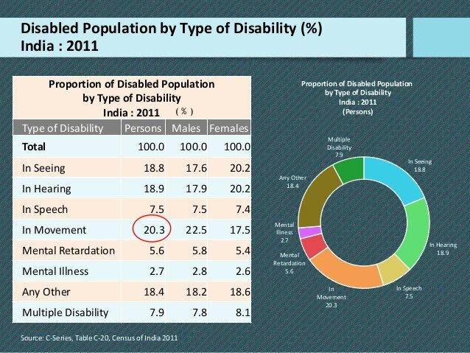

**3.2 PROPOSED METHODOLOGY**

Amazon Echo and Google Home have been one of the most publicized uses of IoT in people’s homes. To use utilities and basic services within a house, people have to no longer depend on switches and conventional physical methods of interaction. For example, IoT devices allow a visually impaired user to change the heat settings without needing to program a controller. These devices work by using a voice recognition system, without any kind of special setup. For people suffering from paralysis or those who are completely bedridden, such technologies are no less than a boon as they perform functions like unlocking a door without In most cases, people with disabilities require constant monitoring which can often be challenging and demanding for them. Michael J Fox Foundation uses IoT devices to monitor hundreds of people with disabilities and long-term illnesses. They gather millions of diverse data points that hold a clue to cure a disease. The data collected is so enormous that it can be used not only for those who are ill and challenged but also to evolve newer models for developing preventive measures for any new kind of disease as well. IoT will break the accessibility barriers. IoT-enabled smart environments will create an enabling system that embodies inclusiveness, a smart ecosystem that helps challenged people to live their lives freely.

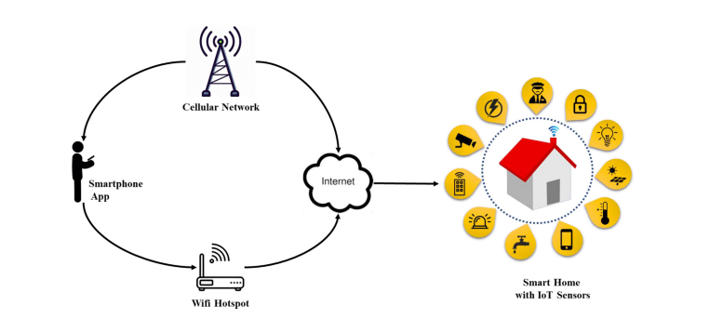

**3.3 MODULE DESCRIPTION**

Internet of Things (IoT) technology has a wide variety of applications and the use of the Internet of Things is growing so faster. Depending upon different application areas of the Internet of Things, it works accordingly as per it has been designed/developed. But it has not a standard defined architecture of working which is strictly followed universally. The architecture of IoT depends upon its functionality and implementation in different sectors. Still, there is a basic process flow based on which IoT is built.

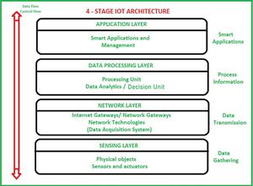

**Sensing Layer**

Sensors, actuators, and devices are present in this Sensing layer. These Sensors or Actuators accept data(physical/environmental parameters), process data, and emit data over the network.

**Network Layer**

Internet/Network gateways and Data Acquisition Systems (DAS) are present in this layer. DAS performs data aggregation and conversion fufunctionsCollecting data and aggregating data then converting analogue data of sensors to digital data etc). Advanced gateways which mainly open up a connection between Sensor networks and the Internet also perform many basic gateway functionalities like malware protection and filtering sometimes decision-making based on inputted data and data management services, etc.

**Data processing Layer**

This is the processing unit of the IoT ecosystem. Here data is analyzed and pre-processed before sending it to the data centre from where data is accessed by software applications often termed business applications where data is monitored and managed and further actions are also prepared. So here Edge IT or edge analytics comes into the picture.

**Application Layer**

This is the last layer of the 4 stages of IoT architecture. Data centres or cloud is the management stage of data where data is managed and is used by end-user applications like agriculture, health care, aerospace, farming, defence, etc.

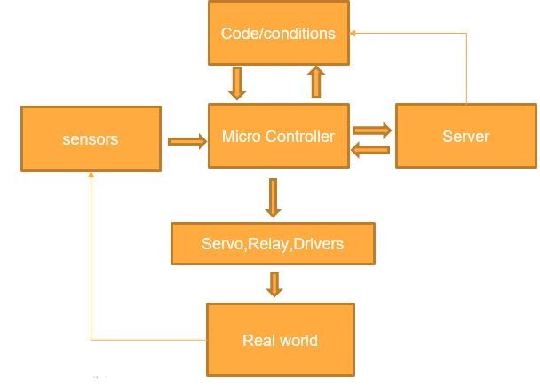

**3.4 Proposed framework**

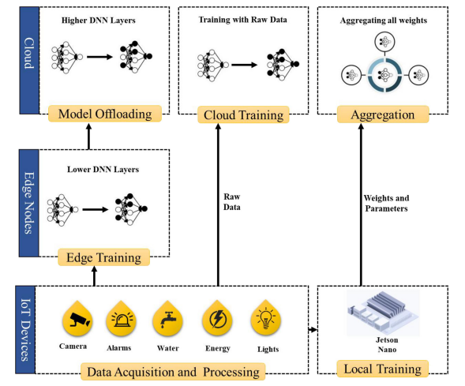

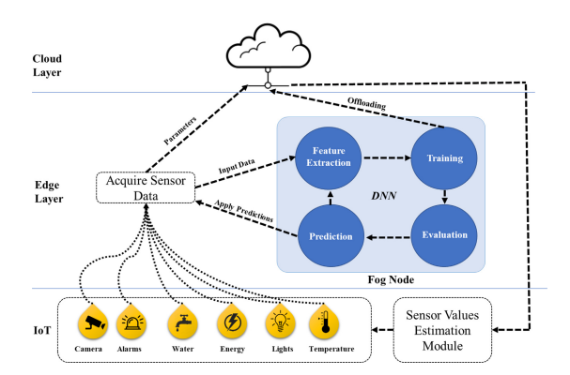

Home automation, security, safety, privacy, and energy consumption is an emerging field of technology and can be implemented with different microcontrollers and processors i.e., Desktop PC, laptops, Raspberry Pi, Arduino, etc., All these microcontroller and processors have their pros and cons, but Raspberry Pi is more versatile and efficient option compared to other units. The smart home concepts can have many components including 1) Sensors, 2) Gateways, 3) Protocols, 4) Firmware and 5) Cloud-based databases. The main focus of bringing AI to the smart home is to automate certain processes that need more than thresholds and pre-defined configurations. For example, one such task is fall detection. The process of integrating AI in the smart home is more natural and requires a significant amount of computational overhead. Today, most of the data generated by IoT devices resides outside the scope of the cloud so it is more natural to bring the machine learning capabilities closer to the source of the data and reduce the amount of bandwidth it consumes by transferring the entire dataset for each training session. Therefore, we leverage an approach called mobile edge compcomputinere the collaborative nature of the architecture makes it easy to train data locally on the device, and then send data to the higher-level layers of the DNN to train it on the edge server. The remaining data is relayed to the cloud where the resource-intensive tasks are offloaded and the remaining mode is trained on the cloud d.the architecture derived from federated learning proposed by Konecˇny´ et al. The authors proposed a method called on deon-demand learning co-inference with edge synergy. The authors argue that using the right sizing approach for DNN layers, the early exit point of the layer must be maintained to offload computationally intense tasks to the cloud from the compacomparativeurce constraint devices. We make use of the same technique discussed here and build upon our framework to work with SqueezeNet for fall detection using Jetson Nano as an edgaedgerocessing node. In this architecture, the data acquisition and processing layer acquires data and is processed locally on the Raspberry Pi as it is the main processing device for IoT devices. The Raspberry Pi itself is not capable of training the model as it lacks GPUthe capabilities that Jetson Nano possesses. The Jetson Nano receives the data and trains a preliminary model for text and multimedia data acquired from the surveillance camera. The multimedia data from the surveillance cameras are much larger in size compared to other devices, therefore the data is trained on the edge node, where the deep learning model is trained using Jetson Nano capable of performing certain levels of computation. However, we assume that the number of multimedia devices may grow in the future and the edge device mentioned here may not respond to all data for training. For this purpose, we split the model and lower-level layers are placed on the server, while the rest of the higher-level layers of the DNN are placed on the cloud with presumably an infinite amount of resources. The cloud model can receive weights from the edge server, it can also update parameters sent from the Jetson Nano or it can also be trained by the data directly sent to the cloud by the IoT devices themselves however, the data sent by the devices directly can compromise the acy and may require additional security. The aggregation module of the cloud layer provides means of aggregation for all parameters sent to the cloud and it helps update all the weights of a single model that can send predictions and estimations along with trends to the IoT devices. To deploy AI services through the cloud, we make use of cloud services provided by Amazon, called Amazon Web Services. It provides off-the-shelf technologies to integrate and deploy AI in IoT applications without too many complications. Moreover, it has a built-in dashboard to support Jetson Nano and is compatible with most IoT applications in general. Details of the working of the edge device and device-based learning for the IoT devices are presented in Fig. 3. The edge layer is equipped with a slightly more powerful device Jetson Nano that acts as a Fog Node and performs machine learning tasks for text and multimedia data. The device receives data and sends it to a feature extraction model. Then the features are sent to train the model itself, where they can be assessed for offloading the cloud or evaluated for training accuracy. The final predictions are sent back to the device and thereafter to the cloud for storage and updating of the cloud-based learning model. The cloud sends updated parameters to the Raspberry Pi which controls and overlooks the connected IoT devices. In this case, the Raspberry Pi changes the values of certain IoT devices like temperature sensors, and surveillance cameras to change parameters. For instance, the temperature sensor can raise the threshold based on the values sent by the cloud model for the next day. In the case of water management, the estimation module can predict the water requirements for the day based on values estimated by the model on previous days of the week. The estimation module uses a REST API and MQTT protocol to connect to the devices and updates the relevant sensor with appropriate results received from the model.

**CHAPTER 4**

**RESULT**

**4.1 Implementation of the security monitor camera**

Tinkerers will recognize the Esp32 as one of the most versatile microcontrollers, with its small footprint, powerful processing capabilities, and onboard wireless connectivity. Building upon its predecessor, the Esp8266, the Esp32 is one of the most popular wireless microcontroller boards and a great choice for wireless projects. The Esp32-Cam adds another useful feature to the mix of a camera. The Esp32-Cam brings together some impressive features, with a dual-core 32-bit processor, ultra-low-power modes for increased battery longevity, up to 34 programmable GPIO pins, a Hall effect (magnetic) sensor, capacitive touch sensors, as well as Bluetooth 4.2 and 802.11b/g/n Wi-Fi connectivity. All these features fit within a package that is just 40 x 30 x 5 mm. These features make it an ideal choice for any sort of Internet of Things (IoT) devices, hosting HTML pages, or streaming videos over the internet

